On 31st January 2025, we visited **AmulFed Dairy, Bhat**, as part of an industrial visit organized by our college, **Government Engineering College, Gandhinagar**. The visit aimed to provide us with insights into industrial automation, large-scale dairy production, and the structured supply chain management that has made Amul the leading dairy brand in India and Asia.

**Introductory Session to Amul**

The visit commenced with a detailed video presentation showcasing the history, evolution, and success story of Amul. Our visit coordinator explained us how Amul started as a small dairy cooperative union and gradually transformed into a global dairy giant.

We learned about the contributions of **Karsandas Patel** and **Dr. Verghese Kurien**, the key figures behind Amul’s establishment. Dr. Kurien, known as the Father of the White Revolution, played a pivotal role in transforming India from a milk-deficient nation to the world's largest producer of dairy products. The presentation highlighted the formation of the **Gujarat Cooperative Milk Marketing Federation** and how Amul’s structured cooperative model contributed to its remarkable success.

The coordinator also emphasized how Amul diversified its product range, expanding beyond dairy products like milk, butter, and cheese to premium offerings such as chocolates, ice creams, and other dairy-based items. We were also introduced to the **Dairy Management System (DMS)** interface, an advanced digital platform that optimizes Amul’s supply chain by ensuring efficient distribution of dairy products across the country. The coordinator explained how Amul has expanded its reach not only across India but also internationally.

Additionally, the R&D Association of Amul is actively working on enhancing livestock fertility, improving pasture management, and ensuring high milk yield. This continuous effort in scientific advancements & automation is helping Amul maintain its position as a leader in the dairy industry.

After gaining valuable insights through the introductory session, we proceeded with the guided tour of the entire plant. The AmulFed Dairy at Bhatt is equipped with cutting-edge industrial automation, ensuring hygienic and large-scale production while maintaining product consistency.

**Milk Pasteurization & Storage Process**

The first section of our tour was the milk pasteurization unit. The primary objective of this process is to eliminate harmful bacteria while retaining the essential nutrients of milk.

* In the High-Temperature Short-Time pasteurization process used at the plant, raw milk is rapidly heated to **75°C** for just **2 seconds** and then immediately cooled to a safe storage temperature.
* This destroys pathogenic microorganisms without compromising the taste, texture, and nutritional properties of the milk.
* The milk then passes through cooling chambers, where it is rapidly cooled to maintain freshness.

After pasteurization, the milk undergoes a series of quality control tests to ensure it meets standard pH levels, fat content, and other edible parameters. These tests verify if the milk is free from contaminants and meets industry safety regulations.

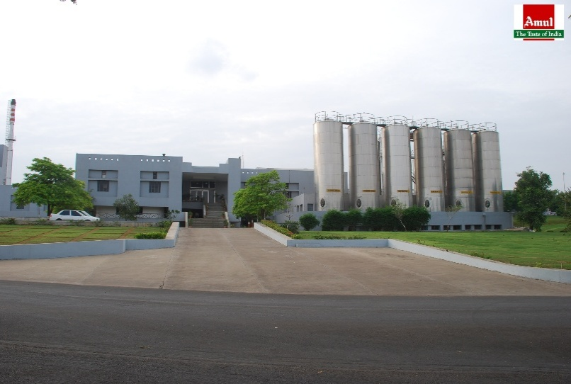

Once the milk passes all quality checks, it is transported through stainless steel pipelines to large-capacity storage silos. The plant has multiple 50,000-litres & 1,00,000-litres silos, allowing a total storage capacity of **60 lakh litres** of milk. These silos are hermetically sealed.

**Milk Packaging Unit**

The next stage took us to the milk packaging unit, where we observed the high-speed, automated packaging systems.

* Milk from storage silos is fed into a fully automated pipeline network, and directed to the packaging lines.
* The packaging process is controlled using a combination of PLCs, robotic grippers, and conveyor belt systems, reducing human intervention and ensuring high precision.
* The plant utilizes the **RMC packaging system**, which efficiently seals and packages milk in pre-formed pouches while maintaining airtight conditions to prevent spoilage.
* Up to **12 to 15 lakh litres** of milk is packaged daily, catering to consumer demands.

To manage and oversee the entire operation, the **Siemens SIMATIC HMI** system is deployed. This advanced automation interface provides real-time monitoring and control.

Another fascinating aspect of this unit was the precise engineering of the packaging process, where:

* Infrared sensors detect and reject improperly sealed pouches to maintain high quality.
* Barcoding and laser marking systems imprint essential details such as batch number, manufacturing date, and expiry date on each package before dispatch.

**Tetra Pack Production & Beverage Packaging Unit**

Now, we visited the Tetra Pack production unit, where various Amul products such as lassi, flavoured milk, and fruit drinks are packaged in aseptic cartons.

* This unit operates with high-speed filling and sealing machines are controlled by **Rockwell Automation PLCs.**
* The Tetra Pack technology ensures that liquid dairy products remain fresh for extended periods without refrigeration by creating a multi-layered packaging.
* We were shown the large paper rolls used for Tetra Pack production, which are sterilized, and then fed into packaging machines that cut, fold, and seal them into individual cartons.

The Tetra Pack process follows multiple stages, including:

1. Sterilization of liquid contents using ultra-high temperature processing, to kill harmful bacteria while preserving flavour.
2. Filling the sterile liquid into Tetra Pack cartons in an aseptic environment, preventing contamination.
3. Sealing the cartons using high-pressure sealing technology to ensure durability.
4. Batch coding & quality inspection before moving final cartons to distribution area.

Additionally, we were informed that the leftover packaging waste generated in this unit is recycled within the plant. The waste materials are processed into secondary products, minimizing environmental impact and promoting sustainability.

**Cheese Cube Production Unit**

Another significant part of our visit was the cubical cheese production unit, where Amul’s cheese cubes and processed cheese are manufactured.

* Milk is first coagulated using rennet enzymes, forming curds that are later cut, pressed, and moulded into cubes.
* The cheese undergoes multiple quality tests to check for texture, moisture levels, and pH balance before being packed.
* The automated system ensures uniformity in size and weight by utilizing vision-based cutting and shaping.

**Butter Manufacturing & Packaging Unit**

Our next stop was the butter manufacturing and packaging unit, where we observed production of Amul Butter, one of the most recognized dairy products in India.

* The production of butter begins with churning high-fat cream in large-capacity blending machines, which separate the butterfat from the buttermilk.
* Once butterfat reaches desired consistency, it undergoes continuous blending to maintain uniform texture and taste.
* The plant operates on a batch-wise production system, ensuring high efficiency in each batch.
* On average, the AmulFed Dairy plant produces **100 metric tonnes** of butter daily.

After production, the butter is weighed, and packaged using automated wrapping. The packaging process ensures that the product remains fresh and protected during distribution.

**Ice Cream Manufacturing Unit**

Another significant part of our visit was the ice cream manufacturing unit, where we witnessed the production of Amul’s popular candy bars and chocobars.

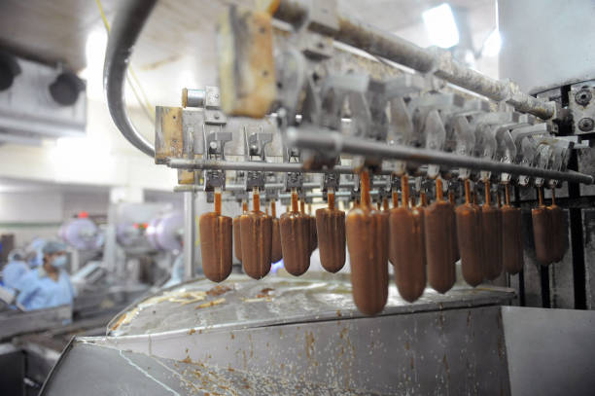

* The process starts with blending high-quality milk, sugar, and emulsifiers in precise proportions to achieve the desired creamy texture.
* The mixture is then homogenized, pasteurized, and rapidly cooled before being transferred to automated filling machines.
* This production line ensures consistent freezing of ice creams at **-25°C to -30°C.**
* Chocobars and other coated ice creams are passed through a chocolate enrobing machine, which coats them evenly before they enter the blast-freezing chamber.

We observed high-speed conveyor belts for packaging and storage. The hygiene control in this unit was impressive, ensuring every ice cream maintains consistent quality & taste.

**Ghee Manufacturing Unit**

Moving forward, we visited the ghee manufacturing and packaging unit, another crucial segment of Amul’s production line.

* Ghee production starts with the slow heating of butter, allowing moisture to evaporate and milk solids to caramelize, giving Amul Ghee its distinct aroma and rich flavour.
* The process is carefully controlled using temperature-monitoring systems to prevent overheating and preserve the nutritional value of the ghee.
* The final product is filtered, cooled, and transferred to automated packaging units, ensuring air-tight packing to maintain freshness.
* The plant has an impressive production capacity of **50 metric tonnes** of ghee daily, meeting high consumer demand.

**Milk Powder Manufacturing & Packaging Unit**

The highlight of our visit was witnessing the production of milk powder, a critical component of AmulFed Dairy’s large-scale operations. This plant is recognized as Asia’s largest milk powder production facility.

* Milk powder production involves the removal of moisture from liquid milk through an industrial-scale spray-drying process.
* The liquid milk is first concentrated through evaporation.
* The concentrated milk is then atomized into tiny droplets and passed through a hot air chamber, where moisture is rapidly evaporated, leaving behind fine milk powder particles.
* This powder is then collected, sieved, and standardized before being directed to the packaging units.

We were informed that **GIA Engineering** machineries are used for the manufacturing and packaging of milk powder, ensuring high efficiency and accuracy in every batch. This level of automation and precision engineering ensures that Amul can produce milk powder at an industrial scale while maintaining superior quality and hygiene standards.

**Conclusion**

This industrial visit to AmulFed Dairy, Bhat, was an invaluable learning experience, offering practical exposure to automation, large-scale dairy processing, and supply chain management. We witnessed the seamless integration of industrial automation across multiple units, reinforcing Amul’s position as a global dairy leader.

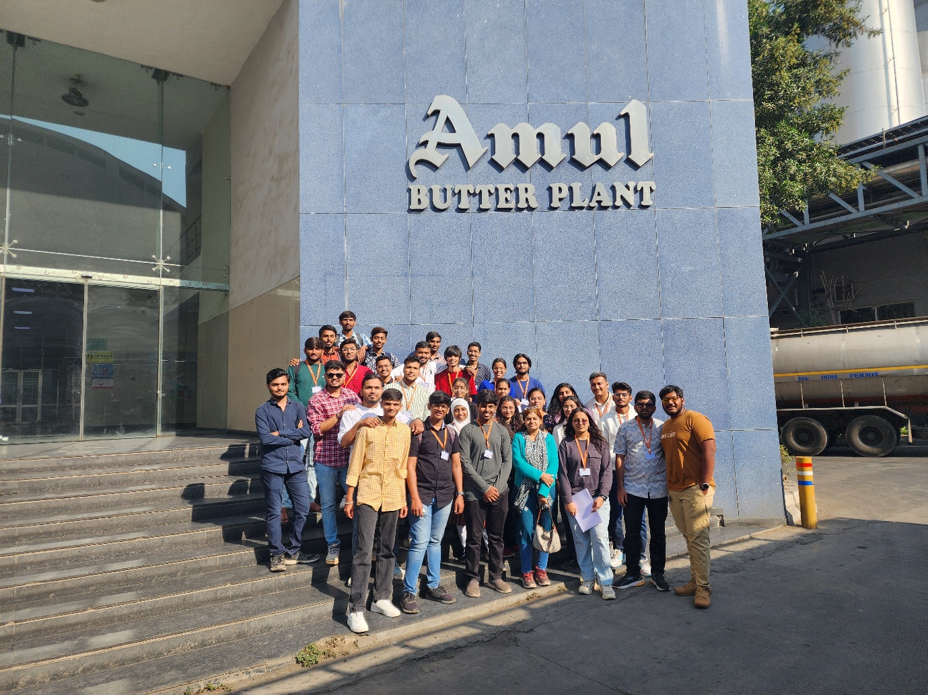

We are extremely grateful to our faculty coordinator **Dr. Darshana Dave** & **Prof.Devangi Desai** for their guidance and support in organizing this visit. Their efforts allowed us to gain first-hand experience of advanced manufacturing processes, which will undoubtedly enhance our technical knowledge & understanding of industrial automation.