- DEPARTMENTAL ACTIVITIES
- Prof. D.D.Mevada and Prof. S.D.Mali coordinated a two day workshop on “Industrial AutoCad, Solid Works” during 3/9/2024 to 4/9/2024.
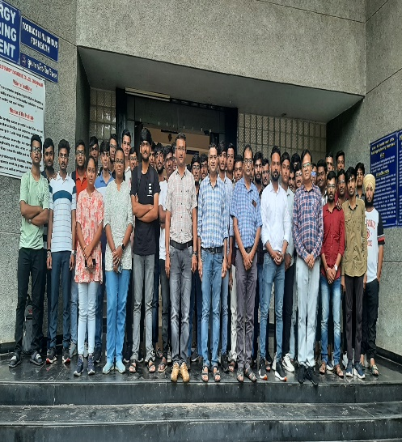 | 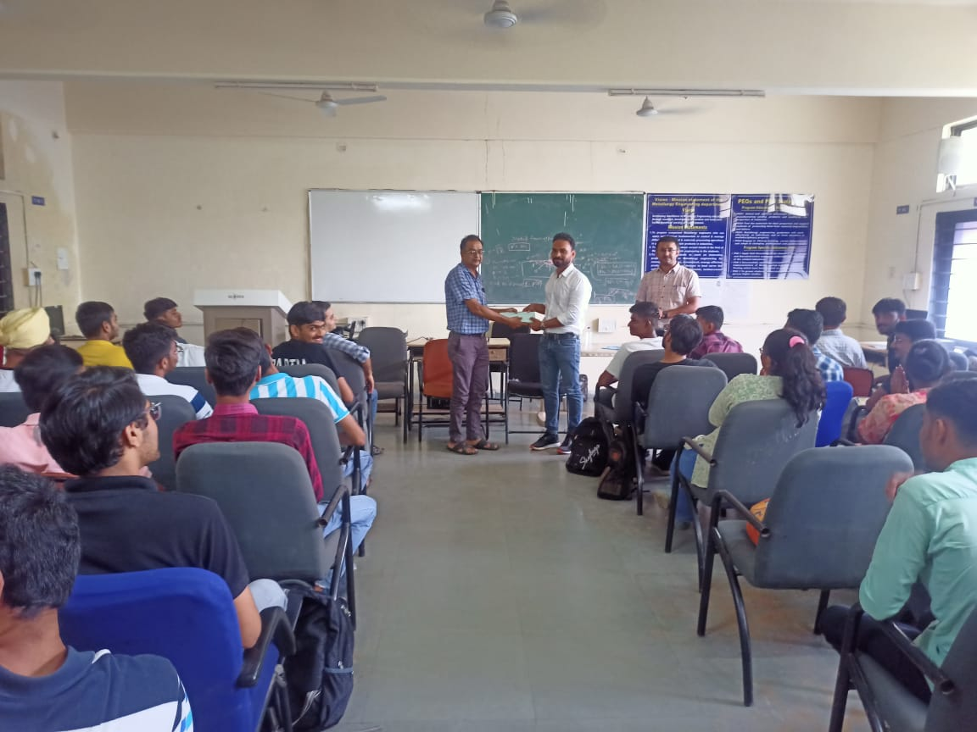
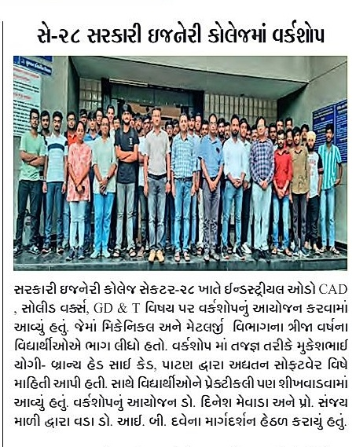 | 