- DEPARTMENTAL ACTIVITIES
One Day Workshop
Prof. K.P.Patel and Prof. R.H.Patel coordinated a one day workshop on “Cost Estimation of Product and its Purchase Procedure” on date 21/9/2024. There are 29 students are participated in the event. Students of mechanical department have taken advantage of the one day workshop.

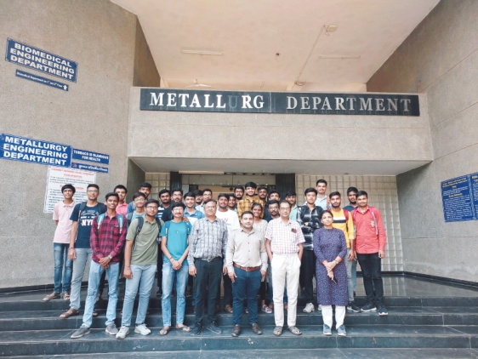 | 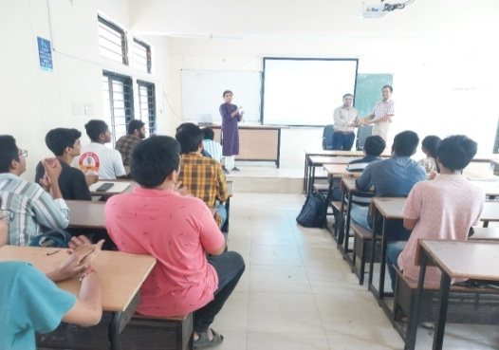
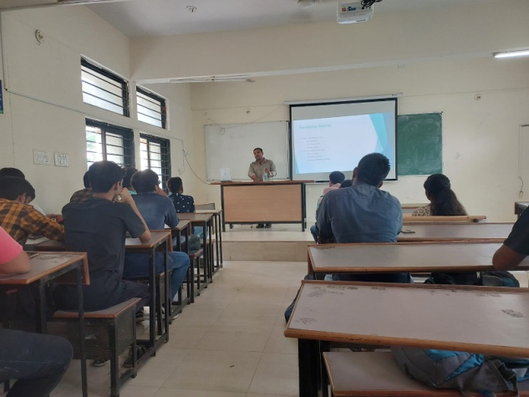 | 