Industrial Visit At Central ST Workshop Visit
- On 4th October 2024, the 5th & 3rd semester Mechanical Engineering students visited the Central ST Workshop in Naroda, Ahmedabad. The visit focused on the practical applications of machine parts used in engines of buses, cars, and other petrol and diesel vehicles. Students were given anin-depth explanation of various engine components, their functioning, and maintenance processes. The workshop provided valuable hands-on learning experiences, linking theoretical knowledge with real-world applications. Transportation to Naroda was smoothly arranged, withbuses provided by the university, ensuring easy and convenient travel for all students. The visit was highly informative and enhanced the students' understanding ofautomotive engineering.

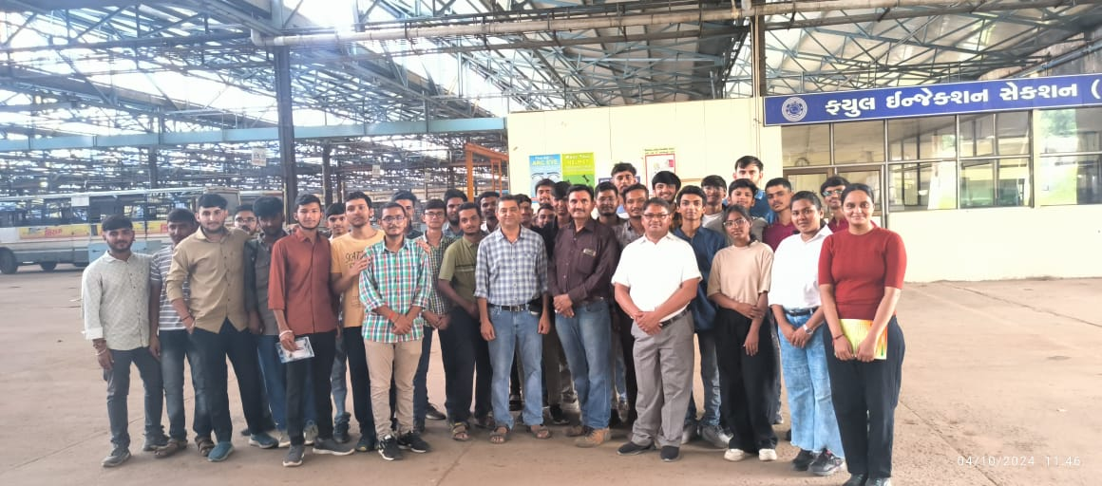 | 