Industrial Visit At Thermal Power Plant Gandhinagar
- Students Of 5 Th Semester Mechanical Department Gec Gandhinagar Had Recently Visited Gandhinagar Thermal Power Station On Date 11/09/2024 Related To Our Curriculum Of Subject Heat Sand Mass Transfer With Our Mentors Prof. K.P.Patel And Prof. R.H.Patel.
- In This Visit As Faculty Guide Of Gandhinagar Thermal Power Station Gave Us A Brief Introduction About Boiler, Types, Power Generation And Capacity Of The Plant. After Presentation Faculty Guide Gave Us Brief Introduction About Boiler And Its Parts, Heat Exchanger, Capacity Etc.

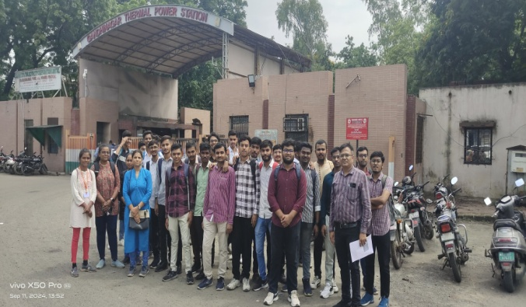 | 